High Level Electricity from Renewables
and the Role of Research and Design

Šimon Buryan
Christian Kozina

Co-operating Universities



Financial support by

Prague and Vienna, 2011

Content

1. Introduction 3
2. The Role of Research and Design 4
2.1. Current Aspects of RES in Electricity Generation Systems 4
2.2. Basic Analysis of a Innovation in Power Industry 5
2.3. Cost-Benefit Analysis 5
3. Fields of Investment for RE Technologies 7
3.1. Investing in RE Technologies 8
3.2. Investing in Research for RES 9
4. Governmental Plans for Research and Design 10
4.1. The Role of Research in Czech National Energetic Conception 10
4.2. Evaluation of Czech National Energetic Conception 11
4.3. The Austrian Energy Strategy 11
5. Conclusions 12

References (Literature) 13

Abstract

From the technical point of view an energy system based on 100% renewable sources is possible. This paper tries to figure out the requirements for such a system, considering today’s technical solutions and the role of research for the solutions of tomorrow; and it compares these findings with the governmental plans in Austria and the Czech Republic. That shows the differences between what the money is invested in and what it might make more sense to be used for.

Introduction

Climate change, decreasing amounts of fossil fuels and the independency in energy production require a shift from conventional power production to renewable sources. In 2008, Austria already generated 71 percent of its electricity from hydro, biomass, wind, waste and photovoltaic. In the Czech Republic, it was only five percent (see table 1).

Table 1: Electricity Production in Austria and the Czech Republic [GWh].
source | Austria (2008) |  | Czech Republic (2008)
coal | 6,898 | 10 % | 49,823 | 60 %
oil | 1,243 | 2 % | 131 | 0 %
gas | 11,204 | 17 % | 2,919 | 3 %
nuclear | 0 | 0 % | 26,551 | 32 %
others | 17 | 0 % | 1 | 0 %
non-renewables | 19,362 | 29 % | 79,425 | 95 %
hydro | 40,678 | 61 % | 2,376 | 3 %
biomass | 4,264 | 6 % | 1,438 | 2 %
wind | 2,014 | 3 % | 245 | 0 %
waste | 753 | 1 % | 21 | 0 %
photovoltaic | 28 | 0 % | 13 | 0 %
geothermal | 2 | 0 % | 0 | 0 %
renewables | 47,829 | 71 % | 4,093 | 5 %
total | 67,101 | 100 % | 83,518 | 100 %
Source: International Energy Agency, 2011a.

Nevertheless both countries face similar challenges on their way to a more sustainable energy system. And on this way, there is one question that is very fundamental: Should the countries start to invest in renewable energy production now or would it be better to use more money for research and design? A difficult question, which this paper will try to find an answer for.

Therefore the next chapter will focus on the role of reasearch and design in general and cite studies about cost-benefit analysis of renewable energies. Based on that the third chapter will try to answer the question which technologies still need a lot of research and which can already be used in an efficient way. Finally, the forth chapter will compare these results with the governmental plans in Austria and the Czech Republic. In this way the authors will try to conclude in which fields more investments would be needed in means of research and design and in which fields it would make more sense to invest directly into building new power plants.

The Role of Research and Design

Renewable Energy Sources (RES) play now a significant role in the electricity generation systems. Their share in the future is likely to rise, which is in many respects a positive outcome. The reason for this is sinking costs of these facilities as well as governmental support in developed countries, which aim at increasing capacity of RES in their electricity generation systems. But this governmental led policy can’t avoid some problems, which are caused by currently used technology. We can name issues such as high volatility of RES or intermittent disconnecting of fossil fuel burning power plants, which can’t get totally shut down. There is a lot of space for improvement, if the share of RES ought to be increased. But role of research and design in current debates over energy policy is often neglected. This chapter will evaluate possible outcomes of investment in research and design with reference to Cost-Benefit Analysis (CBA).

Current Aspects of RES in Electricity Generation Systems

The increasing share of RES is a positive outcome. It enables fossil fuel importing countries to decrease dependency on these fuels. An increasing share of RES enhances their energy security and leads to lowering of CO₂ emissions. On the other hand there are several problems, which mean a difficulty in power supply.

When wind and solar power plants start to produce electricity, they have according current legislation preference right on buy-out of their production. Classical power plants are at this point disconnected from the grid, but they can’t be completely shut down, because a full start-up takes several shifts. Power plants are in a “stand-by mode”, until solar and wind power plants stop to operate due to changes in weather or day period. During this mode power plant is still burning fossil fuels and producing CO_{2,} SO₂, CO and NO_{x} emissions. So there are some quantities of CO₂ produced during production of electricity from solar and wind, but the system of trading carbon credits does not apply to these additional emissions.

Another problem is volatility of RES and low possibilities of storage of power. Connected solar and wind power plants can cause volatility in electrical power network. There were recently many cases in Czech Republic reported, that sudden fluctuation in electric tension, which are originally caused by weather changes, lead to damage of household appliance. Even main Czech operator of electrical power network admits that these cases can happen. These are mostly micro level cases. But there is anxiety that a major break down could happen on macro level. In case of high excess between production and consumption the stability of the whole system can be disturbed.

Basic Analysis of a Innovation in Power Industry

The current political rhetoric is based on conviction that governments in developed countries should increase the share of RES because of the reasons addressed in the beginning of this chapter. But the current technological level of RES (especially wind and solar power plants) would lead to greater instability of electrical power network. There is a lot of possibilities for improvement and innovation of RES and the following chapter will address the issue of expected benefits of financing research and development.

The value of current expenditures on research and development of RES is very low. In 2005 OECD countries invest about 0,006 % of their total GDP in this research. Investment in research of electricity efficiency is even smaller, just 0,004 % of GDP. The value of these expenditures peaked in 1980s. In 1981 OECD countries invested about 0,017% of their GDP in RES research. In 1984 OECD countries spend about 0,015 % of GDP on electricity efficiency. But since 1990s they are fluctuating around the approximate value of 2005.

Government could play a greater part in research and investment due to character of the field of power engineering. Private investment in research of new energetic technologies are associated with lower recovery of investment; approximately 20 – 30 %. If the expenditures come from public funds, the recovery of investment is about 50 %. Private investors can’t appropriate to themselves a greater value of the yield, because their results are being replicated by other competing businesses. If a new discovery is found, soon other entrepreneurs will follow, this will mean a benign outcome for the whole society, but the first investor doesn’t get much back.

The expenditures in research and development could come from public funds, if there would be a greater contribution to the whole society. There are also several forms of reserach, which aren’t covered by private entrepreneurs, because of higher risk of economic return. Government should support especially experimental research, prototype testing or pilot programmes.

Cost-Benefit Analysis

Isabel Galiana and Christopher Green of McGill University carried out a Cost-Benefit Analysis (CBA) of technology-led energetic policy. CBA is a simple way to evaluate a project in financial terms. This method is often used by governments as a basis for decision making, whether to finance a certain project or not.

Galiana and Green put following aspects as imperatives in a favourable policy.

- Basic research and development of new low carbon energy technologies, followed by testing and demonstration;
- Researching and developing technologies that would “enable” the increased scalability of current technologies, such as utility-scale storage for intermittent solar and wind energy;
- Researching and developing ways to reduce the costs of current technologies;
- Energy-related infrastructure, such as smart grids.

Galiana and Green propose a charge on CO₂ emissions, which would finance the proposed approaches. A $5.00 charge imposed on every tonne of CO₂ could raise $150 billion annually, $30 billion in the USA alone. Over time, the carbon charge would be allowed to gradually rise, doubling, every 10 years. In this approach would send a “forward price signal” to deploy new, scalable, cost effective, low-carbon technologies as they would be ready for large scale use.

This analysis was conducted in order to study a technology change as a mean to respond to Climate Change. Some one of the expected benefit from this policy is also avoidance of damage from Climate Change. To estimate these benefits, there were two climate models used, B2 model of IPCC and Prof. Nordhaus’ DICE model. There were also three alternative rates of technological return to R&D considered: an early, mid and late return. The more early scenario enables a faster decrease of carbon intensity (see Figure 1). The last aspect of the analysis was a choosen discout rate; Galiana and Green choose 1,4 %, 3 % and 4 % discount rates.

The analysis at this point operates with relative numbers. Majority of the expected ratios of benefits to costs of technology-led policy are above zero, which means, that benefits exceed costs. (see Table 1) Just one outcome under B2 scenario, which assumes the highest discount rate (4 %), expects a ratio of 0,65 (for every 1 Euro invested, just 0,65 Euro of benefit yields). But let’s consider a median outcome. According to mid return of investment in technology-led policy and 3,0 % discount rate, the benefit-cost ratio should be 2,17 (under B2 scenario) or 3,31 (under DICE scenario). This means, that benefits of investment highly exceed their costs.

The overall result is clear. Investment in research and design in new energetic technologies yield benefits, which highly overpass original costs.
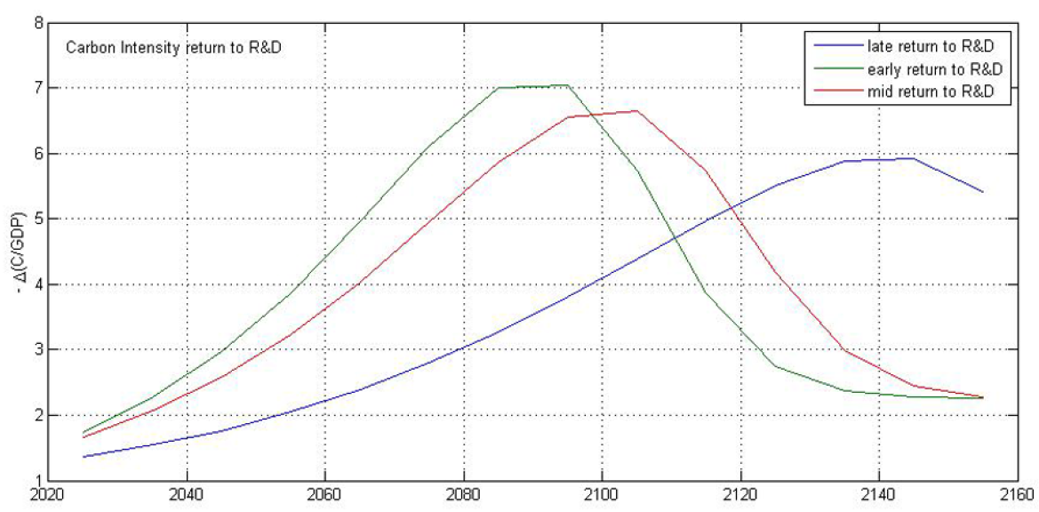
Figure 1: Carbon Intensity Return to R&D: Alternative Profiles
Source: Galiana, Green 2009 p. 45

Table 2: Benefit-cost ratios of Research & Design in time period 2010 – 2110
 | Early return |  | Mid return |  | Late return
Discout rate | B2 | DICE | B2 | DICE | B2 | DICE
1,4 % | 5,21 | 7,56 | 4,58 | 6,92 | 2,41 | 4,75
3,0 % | 2,50 | 3,64 | 2,17 | 3,31 | 1,10 | 2,23
4,0 % | 1,55 | 2,26 | 1,34 | 2,05 | 0,65 | 1,36
Source: Galiana, Green p. 46, 47

Fields of Investment for RE Technologies

Some RE technologies are already competitive with existing energy market prices. For wind power, for instance, it would make sense to invest more money into building new wind turbines instead of financing only research activities. It is a widely known economic principle that the price of buidling turbines would decrease if the number of produced turbines increases. This chapter will focus on this question more deeply.

Investing in RE Technologies

The attractiveness of an energy technology depends on economic, environmental and social aspects as well as the contribution of the technology to meet specific energy services (e.g., peak electricity demands) and the ancillary costs on the energy system (e.g., costs of integration). RES are very attractive from an environmental as well as from a social point of view (see chapter 2). Considering the economic side, at least photovoltaic and ocean electricity become less interesting (see figure 2).

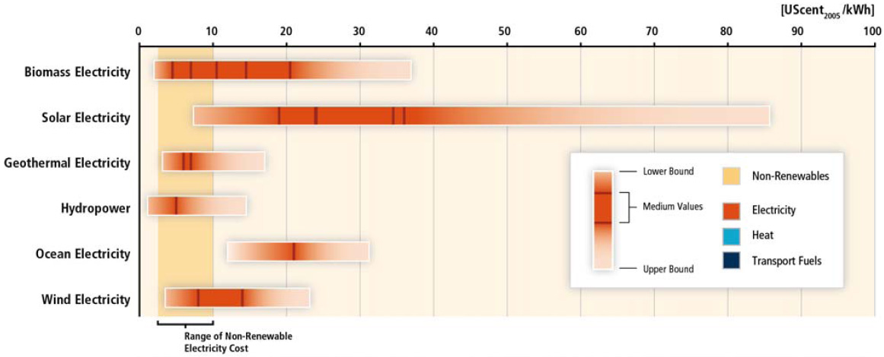
Figure 2: Range in recent levelized cost of energy for selected commercially available RE technologies in comparison to recent non-renewable energy costs.
Source: Intergovernmental Panel on Climate Change 2011 p. 10

Nevertheless this figure means that it would be already reasonable to invest into hydro power, geothermal energy, cofiring biomass and onshore wind electricity instead of building new conventional power plants. These technologies are already competitive and the IPCC expects the costs to go on sinking, whereas the prices for fossil fuels are likely to rise. That means, that there would be high investments in building new renewable power stations if it was possible to integrate them better into the existing energy systems.

But as it was mentioned in chapter 2, the energy systems today are not designed for volatile inputs from sun and wind. High variation in energy supply can lead to severe problems within the electricity distribution. Therefore the question raises how to integrate volatile RES into the power grids of Austria and the Czech Republic. IPCC underlines that “RE can be integrated into all types of electricity systems from large inter-connected continental-scale grids down to small stand-alone systems and individual buildings. Relevant system characteristics include the generation mix and its flexibility, network infrastructure, energy market designs and institutional rules, demand location, demand profiles, and control and communication capability.”
A very important issue here is the network infrastructure: Volatile sources need high capacities to store energy as well as flexible grids that are able to transport variable amounts of electricity. Denmark for instance generates 20 percent of its energy by wind, with peaks of more than 100 percent of demand. That shows that integration of RES is already possible today.

Therefore researchers developed the concept of smart grids: In a smart grid, many different energy providers can follow the load during day and night without blackouts. It connects consumers and producers in an intelligent way by keeping demand and supply at the same level. The freezer for instance would maybe not get energy for one hour if the sun doesn’t shine and the electricity was needed somewhere else. Of course this smart grid technology must be integrated into the energy systems at the same time as the amount of volatile RES is rising over a certain level. That means that it will also be necessary to invest more money into the power grids, instead of only building new wind turbines for instance.

Investing in Research for RES

This might also be answer to the question, what research should focus on: It is obvious that many technologies as wind, hydro power, biomass and geothermal energy will make their way on their own, as there are economic interests to push them. Companies producing these technologies will do a lot of research to make them cheaper and reduce negative external effects. It would make sense if the state supported this research, but as it was shown in chapter 3.1., there is a higher demand of research in fields of energy grids and energy storage, espacially as there is no real economic interest behind that.

Nevertheless the question of high level energy from renewables is not only a technological one. Many studies show that today’s technologies would be good enough to increase the share of RES in electricity production until 2050 in Europe up to 97 percent, in Austria up to 100 percent. Therefore we would only have to find out if we wanted to realize these scenarios and if we did so, how to realize these scenarios. But this is more a societal, economical and political question, and not a question of the availability of technologies. That means that there is a lot of research to be done in these fields as well, which requires investments in a trans- and interdisciplinary research concering economic issues as well as environmental and social aspects. The following chapter will compare these needs with the governmental plans of the Czech Republic and Austria.

Governmental Plans for Research and Design

The main documents, which highlights priorities of Czech government in the field of power industry is National Energetic Conception (NEC). NEC was ratified by the Czech Government in 2004. The current version dates from February 2010. NEC also works with long term prospects to the year 2030.

The Role of Research in Czech National Energetic Conception

Research belongs to six strategic priorities of Czech power industry. NEC accents support of research and innovations, which provide competitiveness of Czech power industry and support of education, due to generation change among brain power and work force.

NEC considers generation change among brain power and work force as an imperative. The average age of employees in Czech power industry is 44. The average age in the whole economy is 40. Another problem is the qualification of employees. In EU-15 about 31 % of employees have a college degree, in Czech Republic just 17 %. Also interest among young generation has to be increased in order to increase the number of employees in power industry.

In the field of research there are individual projects, which are supported by the government according to given grant schemes. NEC admits that there is no concrete strategy of support of certain fields and a mechanism that would enable it. There is also no specialised research centre. This deficit is partially covered by private consulting firms and private research institute. Universities almost don’t play a meaningful role in this field. Several projects are implemented by private firms with limited possibilities of coordination.

NEC aims at improving the current state of brain force and work force in power industry. There are several targets that ought to be fulfilled, such as ensure circa 1 000 of new apprentice in the field of power industry every year or ensure a system of professional association certification of work force, etc. NEC with regard to research proposes to the year 2015 doubling the current amount of financial resources to innovation in the field of power industry branch and machinery industry. Another targets aim at support of universities participation on research projects. NEC proposes also a creation of strategy of development of research and innovation in power industry branch till 2012. There also should be greater coordination of research projects, which are supported by governmental funding.
The main targets of NEC are in regard to research increased participation of Czech research capacities on current and future international research project such as 4th generation of nuclear reactors, nuclear fusion, Carbon Capture technology and other. Applied research should be maximally supported., in the field of basic research, there should be certain research branches defined, where Czech capacities are competitive in European and global scale. Another target aims at support of projects, which increase the efficiency of resource use, or which decrease loses during transmission.

Partial target with regard to research of renewable energy sources strive after support of more efficient use of biomass, development of 2nd generation of bio-fuels, new generation of photovoltaic materials and efficient photocell. In the branch of power transmission NEC proposes increased efficiency of energetic systems, greater integration of individual energy sources. New power grid system (smart grid), which would use decentralised management of the grid, should be also supported.

Evaluation of Czech National Energetic Conception

Czech National Energetic Conception is a broad document, which discusses prospects and plans for future development of Czech power industry. There are references that till 2012 there should be a more narrow strategy of development of research and innovation in power industry created. The documents aims at large list of problems, the documents does not propose any list of priorities of selected types of preferred means of power generation, which should be a central peace of any feasible strategy of development of power industry. This document also mentions that there is a low coordination of individual research project, but this could also be a result of a missing long term vision. One could argue, that every kind of power generation is important, but until the government decides to support in a certain level nuclear energy research more than bio-fuel research or photovoltaic research, we will not get meaningful results. There should be a simple list of issues, which would have a reasonable support, because they are of a great importance to Czech Republic, or because Czech science have capabilities to produce meaningful results.

The Austrian Energy Strategy

The Austrian Energy Strategy was developed in 2010 by officials, lobbyists, economists and scientists as a roadmap for further energy policy in Austria. According to this document, research and design will play an important role for energy efficiency. Austria tries to position itself as a leader in efficient energy technologies.
Furthermore it is said that research in Austria should also focus on information and communication technologies for a better regulation of energy systems. A top position should be reached through pioneer projects and broad testing of new technologies. Smart grids will play an important role in this connection.

A very central problem addressed by the Energy Strategy is the gap between governmental funding of new technologies and market maturity. This is considered to be the reason for a stop of innovation. To avoid this Austria is willing to create an innovation friendly politic and economic environment that makes it easier for new technologies and services to get ready for the market.

Nevertheless the role of research and design is not very clear in this strategy. The focus is on technological solutions, although economic question are addressed as well. The role of a vision for a truly sustainable energy economy for 2050 that guides Austrias climate and energy policy and the demand of research behind that is not visible at all, although this ought to be one of the most crucial points in the whole discussion. In the same way it is not mentioned how to remove barriers for RES, which would require a lot of research
too.

Conclusions
From a technical point of view, it will be no problem to switch to 100 percent renewable energies. Ecological and social impacts are expected to be very positive. Economically it would already be reasonable to invest into hydropower, geothermal energy, cofiring biomass and onshore wind electricity instead of building new conventional power plants. Furthermore, investment in research and design in new energetic technologies yield benefits, which highly overpass original costs. Many technologies have already reached market maturity, others need to be supported a little bit more. To solve the problem of volatility, technological research is especially needed in the fields of energy grids and storage. There is still a lot of space for innovation.

But in contrast, governmental plans about the further steps are not very clear. The share of investment in research on total GDP of OECD countries is low and since 1990s it is fluctuating around the same levels. The documents in Austria and the Czech Republic show lists with different measures, but they do not say who will do what and when. In terms of research and design some important issues are missing, although investment in the fields have very high long term benefits, which exceed the initial costs about two or three times. Therefore governments will have to decide very clearly which way they want to go. Otherwise it will be difficult to bring the different fields of research together to a useful long term strategy. ■

References (Literature)

BURYAN, Petr. Vliv povolenek na snižování emisí oxidu uhličitého. Plyn (Gas) Magazine, Volume 6, June 2011, (in print)
Galiana, Isabel. Green, Christopher. An Analysis of a Technology-led Climate Policy as a Response to Climate Change. [online] 2009 [cit. 2011-04-05] Available at <http://fixtheclimate.com/fileadmin/templates/page/scripts/downloadpdf.php?file=/uploads/tx_templavoila/AP_Technology_Galiana_Green_v.6.0.pdf>.
International Energy Agency. IEA Energy Statistics for Electricity/Heat. [online] 2011a [cit. 2011-05-30] Available at <http://www.iea.org/stats/prodresult.asp?PRODUCT=Electricity/Heat>.
International Energy Agency. IEA Energy and Technology R&D Statistics Service. [online] 2011b [cit. 2011-04-05] Available at <http://www.iea.org/stats/rd.asp>.
INTERGOVERNMENTAL PANEL ON CLIMATE CHANGE. Special Report Renewable Energy Sources. Summary for Policymakers [online] 2011 [cit. 2011-05-12] Available at
<http://srren.ipcc-wg3.de>.
LIND, M. et al. (2009): Ecogrid.dk Phase 1. WP2: System Architecture. Steps toward a Danish power system with 50% wind energy. Teknologisk Institut Århus, 156 p.
Ministry of Industry and Trade of Czech Republic. Státní energetická koncepce ČR. [online] 2010a [cit. 2011-04-05] Available at <http://www.mpo.cz/dokument5903.html >
Ministry of Industry and Trade of Czech Republic. Aktuální verze návrhu "Aktualizace Státní energetické koncepce" - únor 2010. [online] 2010b [cit. 2011-04-05] Available at <http://www.mpo.cz/dokument5903.html>.
Neuhoff, Karsten. SELLERS, Rick. Mainstreaming New Renewable Energy Technologies. European Economic Review. [online] 2006 [cit. 2011-04-05] Available at <http://www.dspace.cam.ac.uk/bitstream/1810/131681/1/eprg0606.pdf>.
STREICHER, W. et al. (2010): Energieautarkie für Österreich 2050. Vienna, 141 p.
TESKE, S. et al. (2010). Energy Revolution. Towards a fully renewable energy supply in the EU 27. EREC – European Renewable Energy Council, 68 p.
TRAMBA, David. Energetici se bojí léta. Lidové noviny, Volume 81, 6th April 2011. p. 1, 16

Buryan 2011
Tramba 2011 p. 1
Tramba 2011. p. 16
International Energy Agency 2011b
International Energy Agency 2011b
Neuhoff, Sellers, 2006 p. 14
Galiana, Green 2009 p. 37
Galiana, Green 2009 p. 57
The discount rate signals a different value of current and future gains. The CBA analysis operates with current value of costs and benefits.
Galiana, Green 2009 p. 44
Intergovernmental Panel on Climate Change 2011 p. 9
Lind et al. 2009
Intergovernmental Panel on Climate Change 2011 p. 9
Intergovernmental Panel on Climate Change 2011 p. 10
Intergovernmental Panel on Climate Change 2011 p. 14
Teske et al. 2010 p 17
Lind et al. 2009 p 9
Teske et al. 2010 p 17
Intergovernmental Panel on Climate Change 2011 p. 14
Taske et al. 2010 p 7, sdftdfz
Streicher et al. 2010 p V
Ministry of Industry and Trade of Czech Republic 2010a
Ministry of Industry and Trade of Czech Republic 2010b p. 14
Ministry of Industry and Trade of Czech Republic 2010b p. 21
Ministry of Industry and Trade of Czech Republic 2010b p. 21
Ministry of Industry and Trade of Czech Republic 2010b p. 22
Ministry of Industry and Trade of Czech Republic 2010b p. 22
Ministry of Industry and Trade of Czech Republic 2010b p. 43
Ministry of Industry and Trade of Czech Republic 2010b p. 44
BMWFJ 2010 p. 32
BMWFJ 2010 p. 94
BMWFJ 2010 p. 32
Teske et al. 2010 p. 9

